DSA0602 – Data Handling and Visualization
Slot D
CO1 – AT2
Name: S.Naveen Kumar
R.No: 34 Reg. No: 192425176

Q1: Color Scales for Data Representation [R]
Employee | Performance Score
E1 | 62
E2 | 78
E3 | 85
E4 | 70
E5 | 91
E6 | 55

1. R program – bar chart with a sequential colour scale
library(ggplot2)

df <- data.frame(
Employee = c("E1","E2","E3","E4","E5","E6"),
Score = c(62, 78, 85, 70, 91, 55)
)

ggplot(df, aes(x = Employee, y = Score, fill = Score)) +
geom_col(colour = "black") +
geom_text(aes(label = Score), vjust = -0.5) +
scale_fill_gradient(low = "#DEEBF7", high = "#08306B",
name = "Performance Score") +
labs(title = "Employee Performance Score",
x = "Employee", y = "Performance Score") +
ylim(0, 100) +
theme_classic(base_size = 12)
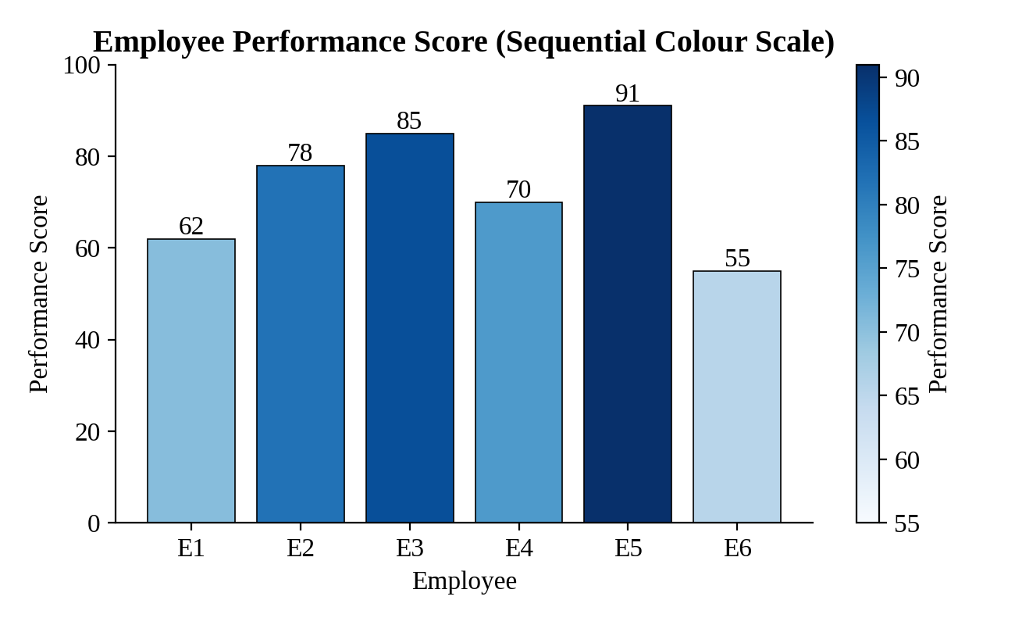
Figure 1: Bar chart of Performance Score using a sequential colour scale

2. Highest and lowest performers
The darkest bar is Employee E5, with the highest score of 91. The lightest bar is Employee E6, with the lowest score of 55. E3 (85) is the second-highest performer.

3. Why a sequential colour scale is appropriate
Performance Score is a continuous, ordered numeric variable that runs from low to high. A sequential scale uses a single hue that changes in lightness, so a darker shade directly means a higher value. Viewers can rank employees and judge the size of differences at a glance without consulting a legend.

4. Colour palette suitable for colour-blind users
Palettes that vary mainly in lightness rather than in red–green hue are safe. Good choices are the ColorBrewer sequential palettes (Blues, YlGnBu), the viridis family (scale_fill_viridis_c()), and the Okabe–Ito palette for categorical data. Red–green combinations should be avoided. Using direct value labels on the bars adds a second, colour-independent cue.

5. Sequential vs categorical colour scales
Aspect | Sequential scale | Categorical (qualitative) scale
Data type | Ordered / numeric (low to high) | Nominal groups with no order
Colour logic | One hue, varying lightness or saturation | Distinct hues of similar lightness
Meaning | Darker = larger value | Each colour is only a label for a group
Example | Performance Score, temperature | Category: Electronics, Grocery, Fashion

Q2: Nonlinear Axes [R]
Week | App Downloads
1 | 50
2 | 95
3 | 180
4 | 400
5 | 820
6 | 1600
7 | 3100

1. R program – linear y-axis
library(ggplot2)

apps <- data.frame(Week = 1:7,
Downloads = c(50, 95, 180, 400, 820, 1600, 3100))

p_linear <- ggplot(apps, aes(Week, Downloads)) +
geom_line(linewidth = 1) + geom_point(size = 3) +
geom_text(aes(label = Downloads), vjust = -1) +
scale_x_continuous(breaks = 1:7) +
labs(title = "App Downloads per Week (Linear Axis)",
x = "Week", y = "App Downloads") +
theme_classic(base_size = 12)
p_linear
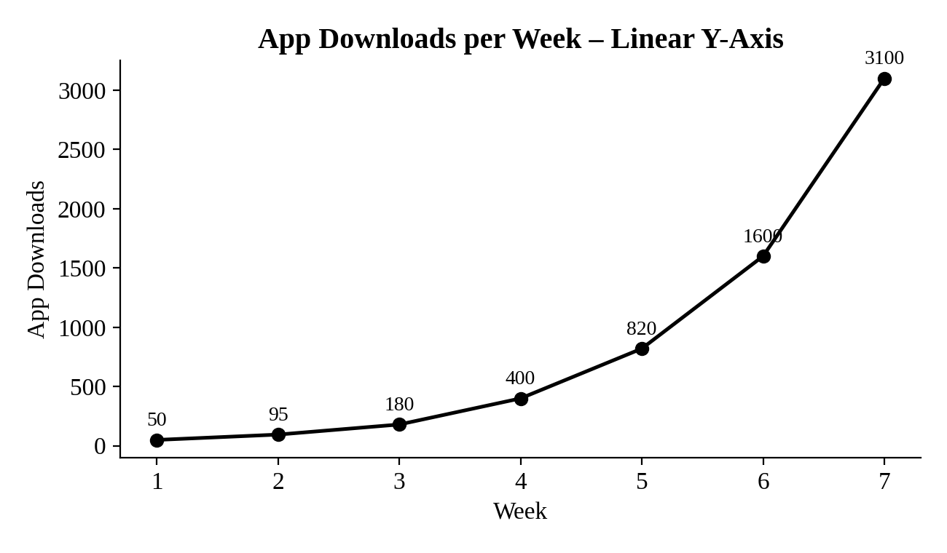
Figure 2: App Downloads with a linear y-axis

2. R program – logarithmic y-axis
p_log <- p_linear + scale_y_log10() +
labs(title = "App Downloads per Week (Log10 Axis)",
y = "App Downloads (log10 scale)")
p_log
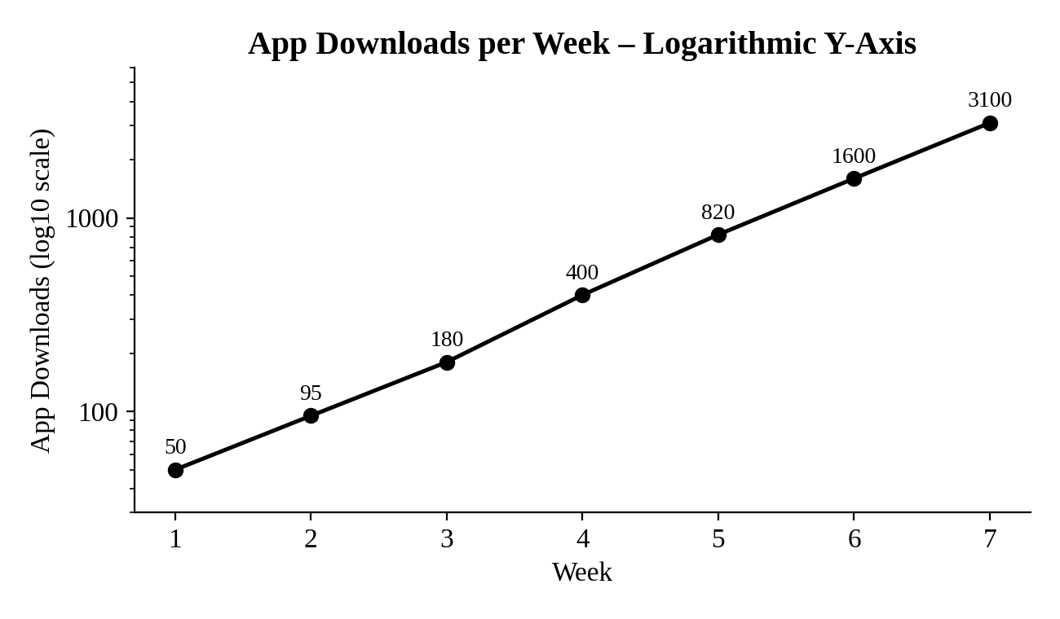
Figure 3: App Downloads with a logarithmic y-axis (scale_y_log10)

3. Comparison of both visualizations
On the linear axis the curve is almost flat for Weeks 1 to 3 and rises steeply after Week 5. The early values (50, 95, 180) are squeezed near the bottom and are hard to read. On the logarithmic axis the points fall close to a straight line. Each week the downloads roughly double (ratios of about 1.9, 1.9, 2.2, 2.1, 2.0 and 1.9), so the growth is exponential at a nearly constant rate, and every week is equally readable.

4. Why a logarithmic scale suits this dataset
The values span more than one order of magnitude (50 to 3100) and grow multiplicatively. A log scale gives equal vertical distance to equal percentage changes, which shows the growth rate clearly. It also keeps small and large values visible in the same plot, and a straight line immediately signals exponential growth.

5. A situation where a logarithmic scale should not be used
A log scale cannot be used when the data contain zero or negative values, because the logarithm is undefined there. Examples are profit and loss figures or temperatures in °C. It is also unsuitable for bar charts, whose bars must start at a meaningful zero baseline, and for audiences who may misread the compressed scale as absolute differences.

Q3: Correlation Heatmap [R]
Student | Attendance (%) | Study Hrs/Day | Sleep Hrs/Day | Marks (%)
S1 | 92 | 3.5 | 6.5 | 88
S2 | 75 | 1.5 | 8 | 62
S3 | 88 | 2.8 | 7 | 80
S4 | 60 | 1 | 5.5 | 48
S5 | 95 | 4 | 7.5 | 91
S6 | 70 | 2 | 6 | 58

1. R program – correlation matrix and heatmap
library(ggplot2)
library(reshape2)

students <- data.frame(
Attendance = c(92, 75, 88, 60, 95, 70),
Study_Hrs = c(3.5, 1.5, 2.8, 1.0, 4.0, 2.0),
Sleep_Hrs = c(6.5, 8.0, 7.0, 5.5, 7.5, 6.0),
Marks = c(88, 62, 80, 48, 91, 58)
)

cor_mat <- round(cor(students), 2)
print(cor_mat)

cor_long <- melt(cor_mat)
ggplot(cor_long, aes(Var1, Var2, fill = value)) +
geom_tile(colour = "white") +
geom_text(aes(label = sprintf("%.2f", value))) +
scale_fill_gradient2(low = "#B2182B", mid = "white",
high = "#2166AC", midpoint = 0,
limits = c(-1, 1), name = "Correlation") +
labs(title = "Correlation Heatmap", x = NULL, y = NULL) +
theme_minimal(base_size = 12)
Correlation matrix obtained:
 | Attendance | Study Hrs | Sleep Hrs | Marks
Attendance | 1.00 | 0.95 | 0.56 | 0.99
Study Hrs | 0.95 | 1.00 | 0.36 | 0.97
Sleep Hrs | 0.56 | 0.36 | 1.00 | 0.49
Marks | 0.99 | 0.97 | 0.49 | 1.00
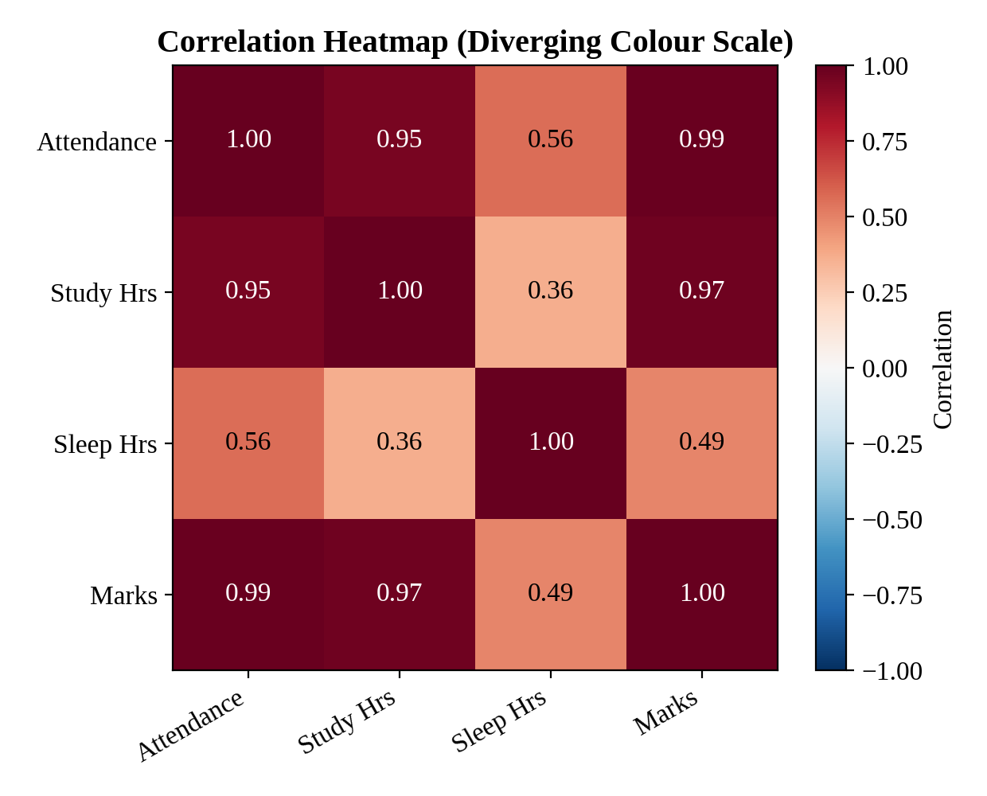
Figure 4: Correlation heatmap with a diverging colour scale

2. Pair with the strongest correlation
Attendance and Marks have the strongest correlation, r = 0.99. Study Hrs and Marks follow closely at r = 0.97, and Attendance and Study Hrs at r = 0.95. The weakest pair is Study Hrs and Sleep Hrs (r = 0.36).

3. Diverging colour scale in a correlation heatmap
Correlation values run from −1 to +1 and have a natural midpoint at 0. A diverging scale assigns one hue to positive correlations, another hue to negative ones, and a neutral light colour to values near zero. The viewer can therefore see the direction (sign) and the strength (intensity) of each relationship at the same time.

4. A limitation of using correlation for this data
Correlation shows association, not causation. High attendance, long study hours and high marks all move together, so we cannot say which one causes the others. In addition, only six students are observed, so the coefficients are unstable and may not generalise. Pearson correlation also detects only linear relationships.

5. An additional variable that could improve the analysis
Prior academic performance (previous semester GPA or internal test scores) would help. It would separate the effect of study habits from a student’s existing ability. Other useful variables are assignment completion rate and the quality of study (for example, practice-test scores).

Q4: Legends and Annotations [R]
Month | Co. X (Rs) | Co. Y (Rs) | Co. Z (Rs)
Jan | 410 | 380 | 450
Feb | 430 | 395 | 460
Mar | 460 | 410 | 440
Apr | 480 | 430 | 470
May | 520 | 460 | 510
Jun | 500 | 490 | 530

1 & 2. R program – multi-series line chart with legend and annotations
library(ggplot2)
library(tidyr)

stock <- data.frame(
Month = factor(c("Jan","Feb","Mar","Apr","May","Jun"),
levels = c("Jan","Feb","Mar","Apr","May","Jun")),
Co_X = c(410, 430, 460, 480, 520, 500),
Co_Y = c(380, 395, 410, 430, 460, 490),
Co_Z = c(450, 460, 440, 470, 510, 530)
)
long <- pivot_longer(stock, -Month, names_to = "Company",
values_to = "Price")

ggplot(long, aes(Month, Price, group = Company,
colour = Company, linetype = Company)) +
geom_line(linewidth = 1) + geom_point(size = 2.5) +
annotate("text", x = 5, y = 538, label = "Highest X: Rs 520") +
annotate("text", x = 5.6, y = 548, label = "Highest Z: Rs 530") +
annotate("text", x = 5.6, y = 478, label = "Highest Y: Rs 490") +
scale_colour_manual(values = c("black", "grey30", "grey60")) +
labs(title = "Monthly Stock Price Trend",
x = "Month", y = "Stock Price (Rs)") +
theme_classic(base_size = 12) +
theme(legend.position = "bottom")
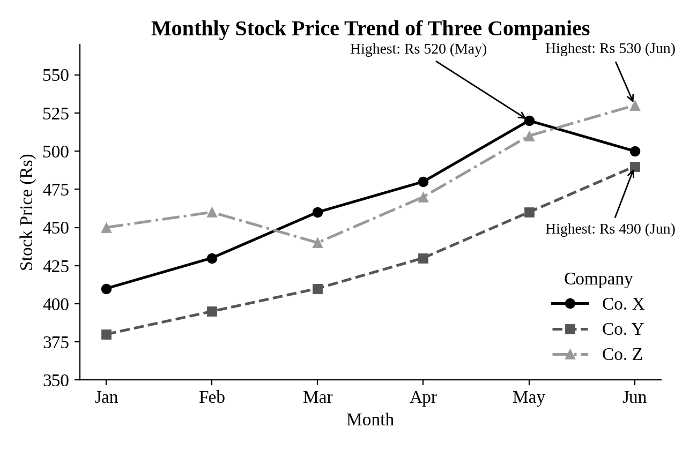
Figure 5: Monthly stock-price trend of Co. X, Co. Y and Co. Z with annotated peaks
Highest prices: Co. X – Rs 520 (May); Co. Y – Rs 490 (Jun); Co. Z – Rs 530 (Jun).

3. Role of legends in multi-series visualizations
A legend links each visual encoding (colour, line type or marker) to the series it represents. Without it the viewer cannot tell which line is Co. X, Co. Y or Co. Z. A good legend has a clear title, matches the exact styling used in the plot, and uses the same ordering as the lines.

4. Best practices for placing legends
- Place the legend outside the plotting area or in an empty region so that it never covers data lines or points.
- Keep it compact, in the same font family as the chart, and order the entries to match the line order at the right-hand end.
- Use a bottom or right position, avoid heavy borders or backgrounds, and show line type as well as colour for accessibility.

5. Alternative to a legend
Direct labelling is a better alternative. The company name is written at the end of each line (with geom_text() or the directlabels / ggrepel packages). The reader then needs no lookup between legend and line, which reduces eye movement and works well for colour-blind readers.

Q5: Mapping Data onto Aesthetics [R]
Item | Orders | Rating (/5) | Category
I1 | 320 | 4.2 | Electronics
I2 | 540 | 3.8 | Grocery
I3 | 210 | 4.6 | Fashion
I4 | 690 | 4 | Grocery
I5 | 150 | 4.8 | Fashion
I6 | 410 | 3.5 | Electronics

1 & 2. R program – scatter plot with colour and size aesthetics
library(ggplot2)

items <- data.frame(
Item = c("I1","I2","I3","I4","I5","I6"),
Orders = c(320, 540, 210, 690, 150, 410),
Rating = c(4.2, 3.8, 4.6, 4.0, 4.8, 3.5),
Category = c("Electronics","Grocery","Fashion",
"Grocery","Fashion","Electronics")
)

ggplot(items, aes(x = Orders, y = Rating,
colour = Category, size = Orders)) +
geom_point(alpha = 0.8) +
geom_text(aes(label = Item), vjust = 2.5, size = 4,
colour = "black", show.legend = FALSE) +
scale_colour_manual(values = c(Electronics = "#1F4E79",
Grocery = "#C55A11",
Fashion = "#548235")) +
scale_size_continuous(range = c(4, 10)) +
ylim(3.2, 5.1) +
labs(title = "Orders vs Rating by Category",
x = "Orders", y = "Rating (/5)") +
theme_classic(base_size = 12)
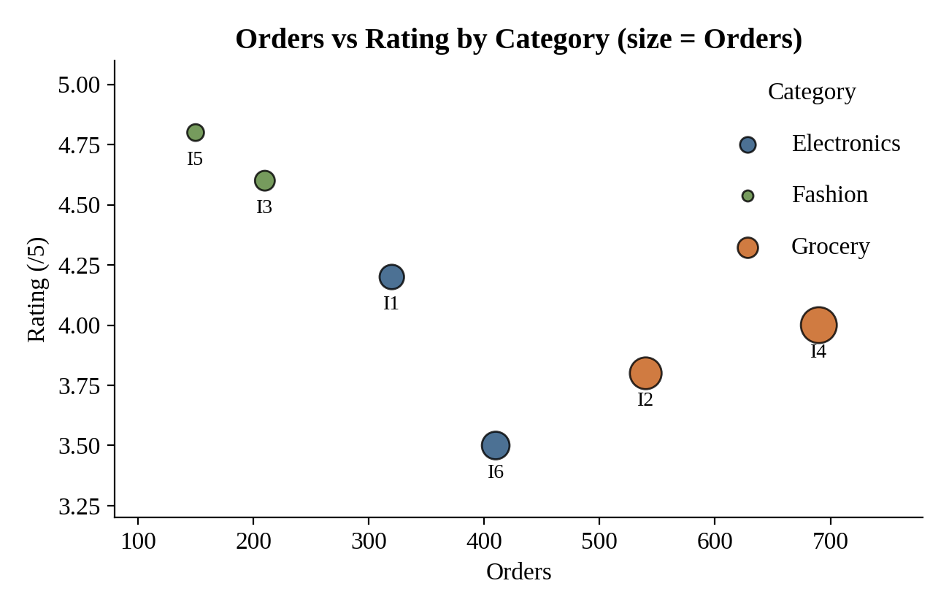
Figure 6: Scatter plot of Orders vs Rating (colour = Category, size = Orders)

3. Relationship between Orders and Rating
The plot shows a moderate-to-strong negative relationship (Pearson r ≈ −0.70). Items with fewer orders, such as I5 (150 orders, rating 4.8) and I3 (210 orders, rating 4.6), have the highest ratings. Items with many orders, such as I4 (690 orders, rating 4.0), have lower ratings. With only six observations this trend is indicative and should be treated with caution.

4. Type of scale for each variable
Variable | Type of scale | Reason
Item | Nominal | Only an identifier (label) for each product
Orders | Continuous (numeric count, ratio scale) | Has a true zero and meaningful differences; mapped to the x-axis and to size
Rating (/5) | Ordinal in nature, plotted as continuous | Ordered 1–5 scale; the averaged values (e.g. 4.2) are plotted on a continuous axis
Category | Nominal | Unordered groups; mapped to colour

5. Alternative visualization
A bubble chart with Category facets (facet_wrap(~Category)) shows the pattern within each category separately. A grouped bar chart or Cleveland dot plot of average Orders and average Rating per Category is another option, and a labelled lollipop chart per item also works well when the number of items is small.

